|  |  |
| --- | --- |
| DATE | 30-10-2023 |
| TEAM ID | DC1D9FB682DE605B5E14ADA9DB49001C |
| PROJECT TITLE | How to Create a Brand Promo Video Using Canva |

**PROJECT REPORT**

**1.OVERVIEW**

**1.1 INTRODUCTION**

Unlock the potential of your project with a captivating promo video crafted right here in Canva! In this guide, we’ll navigate the creative landscape together, seamlessly blending visuals and information to bring your project report to life. Let’s dive into the art of storytelling and design, ensuring your project gets the attention it truly deserves. Welcome to the world of dynamic and engaging project promo videos, made effortlessly in Canva!”

**1.2 PURPOSE**

Creating a promotional video in Canva serves the purpose of visually engaging your audience, conveying your message effectively, and promoting your product, service, or idea. Canva provides user-friendly tools to design and customize videos, making it accessible for individuals and businesses to enhance their marketing efforts through compelling visual content.It’s a visually appealing way to showcase your product, service, or message, making it more shareable and memorable. Canva simplifies the process, allowing you to design a professional-looking promo video even without extensive video editing skills.

**2.PROBLEM DEFINITION AND DESIGN THINKING**

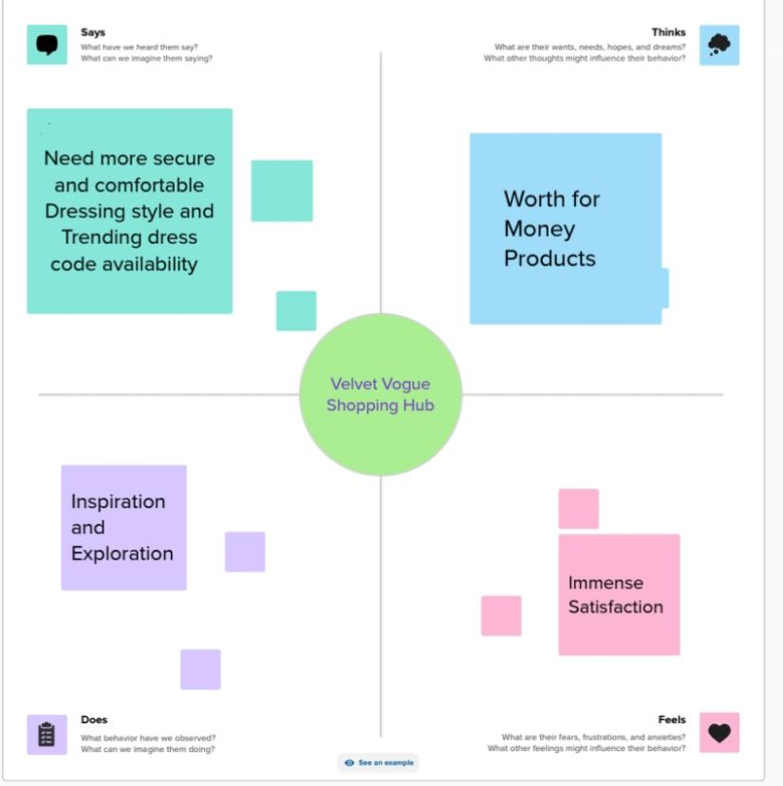**2.1 EMPATHY MAP**

**2.2 BRAINSTORMING AND IDEATION PHASE**

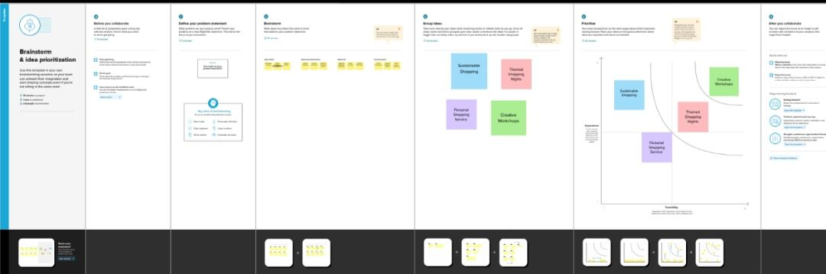

**3.RESULT**

We bad created a promo video to promote digital marketing using Canva with dimensions typically 1080x1920 pixels designated promotion . We have created reel cover using canvas templates,background options,text styles and graphics. We have also uploaded images and videos. Elements have customised by adjusting their size, position and style.Arranged layers according to our liking.

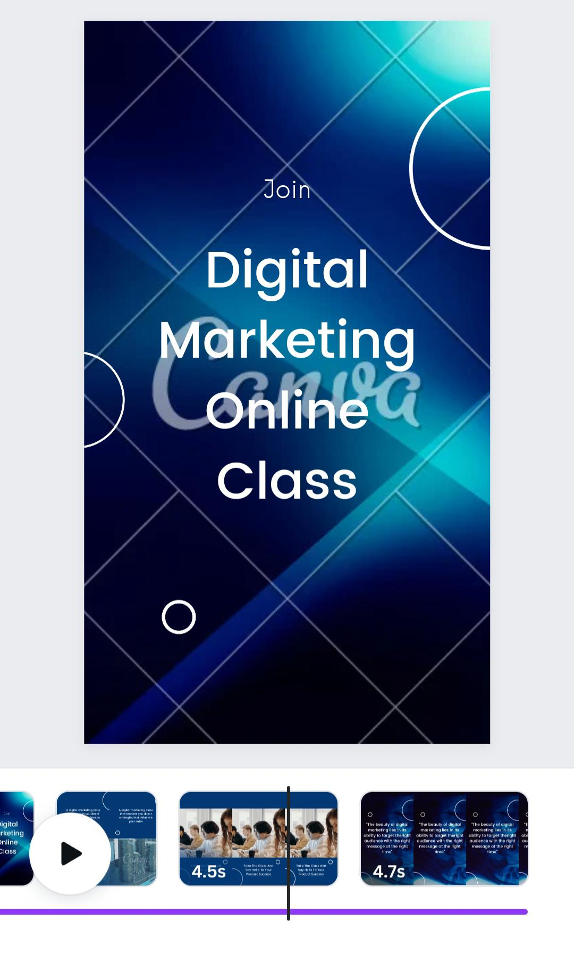We have edited using the combination of multiple videos along with the accurate transition effects of texts with background music and sound effects.

**Here is the link to promo video :**

<https://www.canva.com/design/DAFxzIpk-LA/wZk8Hb-zDlOe92CKbgjY0Q/edit?utm_content=DAFxzIpk-LA&utm_campaign=designshare&utm_medium=link2&utm_source=sharebutton>

Another link with the access

<https://drive.google.com/file/d/1BwBYBcnDjx7tK-wnqstwGacwyWPGw_xs/view?usp=drivesdk>

**4.ADVANTAGES AND DISADVANTAGES :**

**ADVANTAGES :**

1. **Attention-Grabbing:** Promo videos catch the viewer’s eye, increasing the chances of them engaging with your content.
2. **Concise Communication:** They deliver your message quickly and effectively, avoiding information overload.
3. **Shareability:** Easy to share on social media and other platforms, expanding your audience reach.
4. **Brand Recognition:** Visual elements and storytelling enhance brand recall, making your business more memorable.
5. **Increased Conversions:** Engaging videos can drive viewers to take desired actions, boosting conversion rates.
6. **Versatility:** Suitable for various purposes, from product launches to explaining complex concepts.
7. **Credibility:** High-quality promo videos can enhance your brand’s perceived professionalism and credibility.
8. **Emotional Connection:** Videos have the power to evoke emotions, fostering a stronger connection with your audience.
9. **SEO Benefits:** Video content can improve your website’s search engine ranking, increasing visibility.
10. **Adaptability:** Canva’s tools make it accessible for businesses of all sizes, enabling easy video creation without extensive technical skills.

**DISADVANTAGES:**

While promo videos have numerous advantages, it’s essential to consider potential drawbacks:

1. **Cost:** Professional-quality videos can be expensive to produce, involving equipment, software, and sometimes hiring a videographer.
2. **Time-Consuming:** Crafting a compelling video takes time, from planning and shooting to editing, which might not align with tight deadlines.
3. **Skill Requirements:** Creating a polished video may require skills in videography, editing, and storytelling, which not everyone possesses.
4. **Compatibility:** Videos may not be suitable for all platforms or may require specific formats, limiting their versatility.

**5.APPLICATIONS**

The best apps for creating and editing reels were:

* Canva
* Capcut
* Instagram
* Adobe rush
* Adobe express
* Kine master
* Etc…..

**6.CONCLUSION :**

In conclusion, creating promo videos can be a powerful tool for engaging audiences, conveying messages effectively, and enhancing brand visibility. While they offer numerous advantages, such as increased shareability and improved conversion rates, it’s crucial to weigh the potential disadvantages, including cost and time constraints. Striking a balance between creativity, message clarity, and platform suitability is key to maximizing the impact of promo videos in your marketing strategy.

**7.FUTURE SCOPE:**

The future of promo videos holds exciting possibilities. Advancements in technology, such as augmented reality (AR) and virtual reality (VR), may provide immersive promotional experiences. Personalized and interactive videos could become more prevalent, allowing users to engage with content on a deeper level. Artificial intelligence might play a role in optimizing video creation processes, tailoring content to individual preferences.